LAPORAN PRAKTIKUM PENGOLAHAN CITRA DIGITAL
10. SMOOTHING FILTERS IN THE SPATIAL DOMAIN



Disusun oleh :
Nama : Felix
NPM : 2327250059
Kelas : IF41

PROGRAM STUDI INFORMATIKA
FAKULTAS ILMU KOMPUTER DAN REKAYASA
UNIVERSITAS MULTI DATA PALEMBANG
2025
TUTORIAL : SMOOTHING FILTERS IN THE SPATIAL DOMAIN

Goal
The goal of this tutorial is to learn how to implement smoothing filters in the spatial
domain.

Objectives
- Learn how to use the fspecial function to generate commonly used kernels.
- Explore applying smoothing filters to images using the imfilter function.
- Learn how to implement uniform and nonuniform averaging masks.
- Learn how to implement a Gaussian mask.

Procedure
In the first part of this procedure, we will use the imfilter function to implement a 3×3 mean (average) filter. We could easily generate the mask array ourselves (nine values, each equal to 1/9), but the IPT offers a function that will automatically create this and several other commonly used masks.

- Load the cameraman image and prepare a subplot.
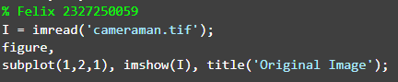
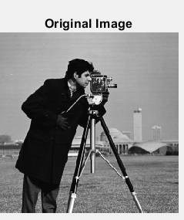

- Create a mean (averaging) filter automatically through the fspecial function.
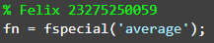
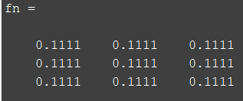

Question 1 Explain what the value of the variable fn represents.
Nilai yang didapat dari rata-rata. Yang dimana matlab akan otomatis 3x3 maka akan cara hitungnya 1/9 =0.1111

Question 2 What other commonly used masks is the fspecial function capable of generating?
Fspecial berfungsi untuk membuat martiks 2d yang berguna untuk pemrosesan citra seperti perataan, penajaman, dsb.

- Filter the cameraman image with the generated mask.
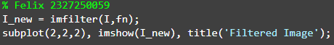
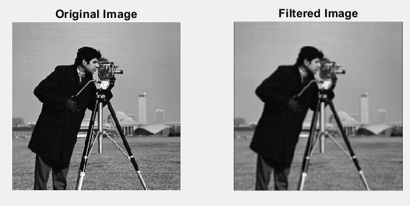

Question 3 What was the effect of the averaging filter?
Efek dari menggunakan imfilter dari fspecial('average') adalah dan bila di zoom warna dai pixelnya lebih rata/ lebih halus, akan tetapi ada kurangnya yaitu ketajaman warna jadi berkurang.

The mean filter we just implemented was a uniform filter—all coefficients were equivalent. The nonuniform version of the mean filter gives the center of the mask (the pixel in question) a higher weighted value, while all other coefficients are weighted by their distance from the center. This particular mask cannot be generated by the fspecial function, so we must create it ourselves.

- Create a nonuniform version of the mean filter.
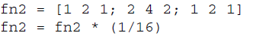
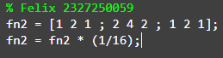
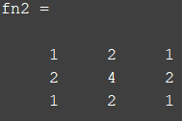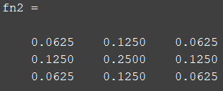

FIGURE 10.1 Uniform and nonuniform averaging masks.

Recall that the uniform mean filter could be created by generating a 3 × 3 matrix of 1’s, and then multiplying each coefficient by a factor of 1/9. In the nonuniform mean filter implantation above, note that the sum of all the original values in the filter equals 16—this is why we divide each coefficient by 16 in the second step. Figure 10.1 illustrates the previous two masks we created.

- Filter the original image with the new, nonuniform averaging mask.
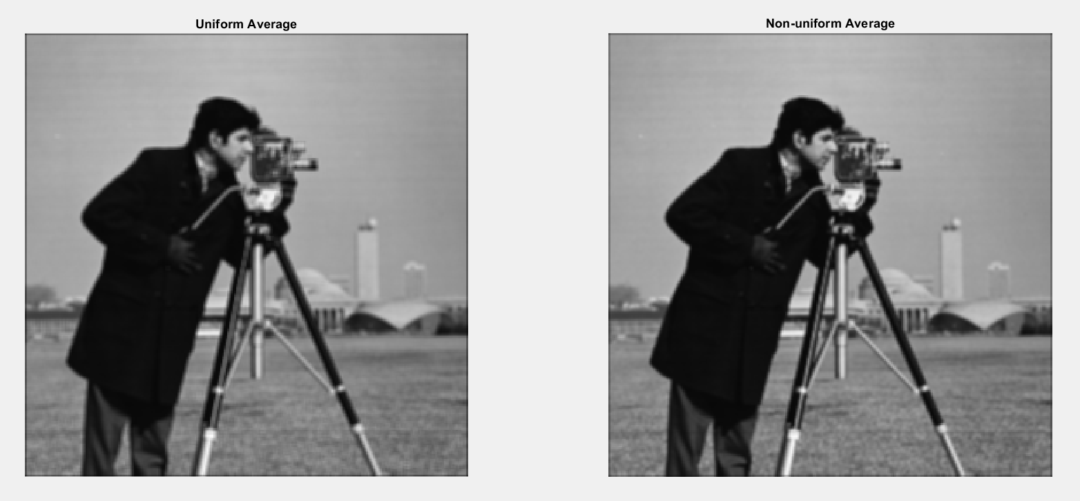

Question 4 Comment on the subjective differences between using the uniform averaging filter and the nonuniform averaging filter.
Perbedaan dari kedua gambar adalah
- Uniform Average (seragam):
Gambar terlihat lebih kabur, dan detail halus seperti tepi objek menjadi kurang jelas.
- Non-uniform Average (tidak seragam/Gaussian):
Gambar terlihat lebih halus namun tetap tajam, terutama di bagian tepi, karena bobot tengah yang lebih tinggi membantu mempertahankan fitur penting.

The Gaussian filter is similar to the nonuniform averaging filter in that the coefficients are not equivalent. The coefficient values, however, are not a function of their distance from the center pixel, but instead are modeled from the Gaussian curve.

- Create a Gaussian filter and display the kernel as a 3D plot.
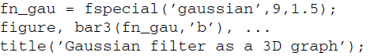
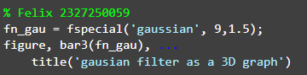
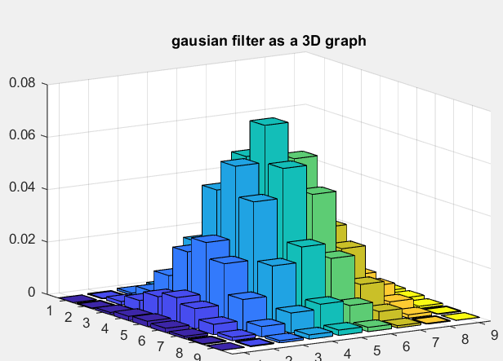

- Filter the cameraman image using the Gaussian mask.
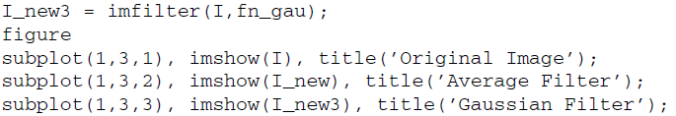
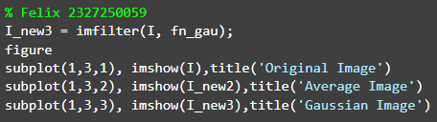
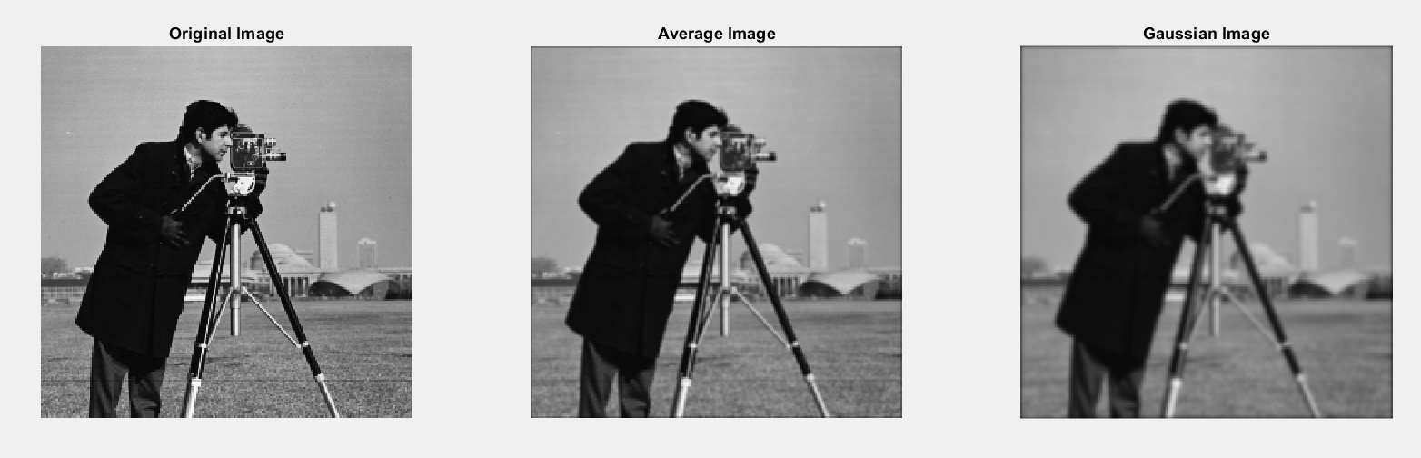

Question 5 Experiment with the size of the Gaussian filter and the value of σ. How can you change the amount of blur that results from the filter?
Cara mengubah keburaman pada gaus adlah dengan cara kita main kan pada sigma-nya, yang dimana semakin besar nilai sigma-nya maka akan semakin buram dan bila 0 maka akan error.

